**EXP 5**

Name: Shashank Sharma

Roll No : J062

1.

int f = 13;

int g = 12;

int e = 11;

int d = 10;

int c = 9;

int b = 8;

int a = 7;

void setup()

{

pinMode(f, OUTPUT);

pinMode(g, OUTPUT);

pinMode(e, OUTPUT);

pinMode(d, OUTPUT);

pinMode(c, OUTPUT);

pinMode(b, OUTPUT);

pinMode(a, OUTPUT);

}

void loop()

{

digitalWrite(f, HIGH);

digitalWrite(g, HIGH);

digitalWrite(e, HIGH);

digitalWrite(d, HIGH);

digitalWrite(c, HIGH);

digitalWrite(b, HIGH);

digitalWrite(a, HIGH);

delay(1000);

digitalWrite(f, LOW);

digitalWrite(g, LOW);

digitalWrite(e, LOW);

digitalWrite(d, LOW);

digitalWrite(c, LOW);

digitalWrite(b, LOW);

digitalWrite(a, LOW);

delay(1000);

}

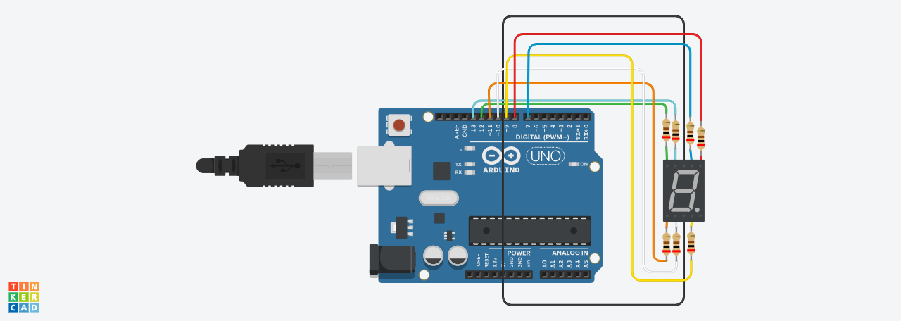

2.

void setup()

{

for (int i = 13; i>=7;i--)

{

pinMode(i, OUTPUT);

}

}

void loop()

{

for (int i = 13; i>=7;i--)

{

digitalWrite(i, HIGH);

delay(500);

}

for (int i=7; i<=13; i++){

digitalWrite(i,LOW);

delay(500);

}

}

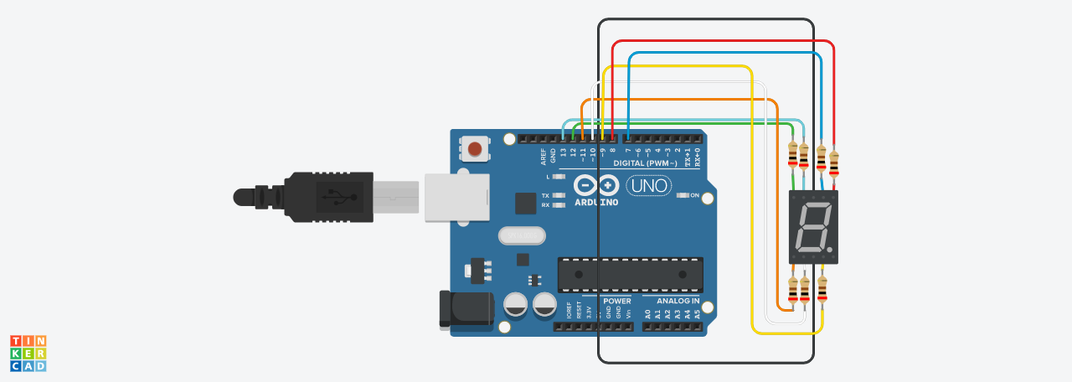

3.

int f = 13;

int g = 12;

int e = 11;

int d = 10;

int c = 9;

int b = 8;

int a = 7;

void setup()

{

pinMode(f, OUTPUT);

pinMode(g, OUTPUT);

pinMode(e, OUTPUT);

pinMode(d, OUTPUT);

pinMode(c, OUTPUT);

pinMode(b, OUTPUT);

pinMode(a, OUTPUT);

}

void zero()

{

digitalWrite(g, 1);

digitalWrite(f, 0);

digitalWrite(e, 0);

digitalWrite(d, 0);

digitalWrite(c, 0);

digitalWrite(b, 0);

digitalWrite(a, 0);

}

void one()

{

digitalWrite(f, 1);

digitalWrite(g, 1);

digitalWrite(e, 1);

digitalWrite(d, 1);

digitalWrite(a, 1);

digitalWrite(b, 0);

digitalWrite(c, 0);

}

void two()

{

digitalWrite(f, 1);

digitalWrite(c, 1);

digitalWrite(a, 0);

digitalWrite(b, 0);

digitalWrite(g, 0);

digitalWrite(e, 0);

digitalWrite(d, 0);

}

void three()

{

digitalWrite(e, 1);

digitalWrite(f, 1);

digitalWrite(a, 0);

digitalWrite(b, 0);

digitalWrite(g, 0);

digitalWrite(c, 0);

digitalWrite(d, 0);

}

void four()

{

digitalWrite(f, 0);

digitalWrite(g, 0);

digitalWrite(e, 1);

digitalWrite(d, 1);

digitalWrite(c, 0);

digitalWrite(b, 0);

digitalWrite(a, 1);

}

void five()

{

digitalWrite(f, 0);

digitalWrite(g, 0);

digitalWrite(e, 1);

digitalWrite(d, 0);

digitalWrite(c, 0);

digitalWrite(b, 1);

digitalWrite(a, 0);

}

void six()

{

digitalWrite(f, 0);

digitalWrite(g, 0);

digitalWrite(e, 0);

digitalWrite(d, 0);

digitalWrite(c, 0);

digitalWrite(b, 1);

digitalWrite(a, 0);

}

void seven()

{

digitalWrite(f, 1);

digitalWrite(g, 1);

digitalWrite(e, 1);

digitalWrite(d, 1);

digitalWrite(c, 0);

digitalWrite(b, 0);

digitalWrite(a, 0);

}

void eight()

{

digitalWrite(f, 0);

digitalWrite(g, 0);

digitalWrite(e, 0);

digitalWrite(d, 0);

digitalWrite(c, 0);

digitalWrite(b, 0);

digitalWrite(a, 0);

}

void nine()

{

digitalWrite(f, 0);

digitalWrite(g, 0);

digitalWrite(e, 1);

digitalWrite(d, 0);

digitalWrite(c, 0);

digitalWrite(b, 0);

digitalWrite(a, 0);

}

void loop()

{

zero();

delay(1000);

one();

delay(1000);

two();

delay(1000);

three();

delay(1000);

four();

delay(1000);

five();

delay(1000);

six();

delay(1000);

seven();

delay(1000);

eight();

delay(1000);

nine();

delay(1000);

}

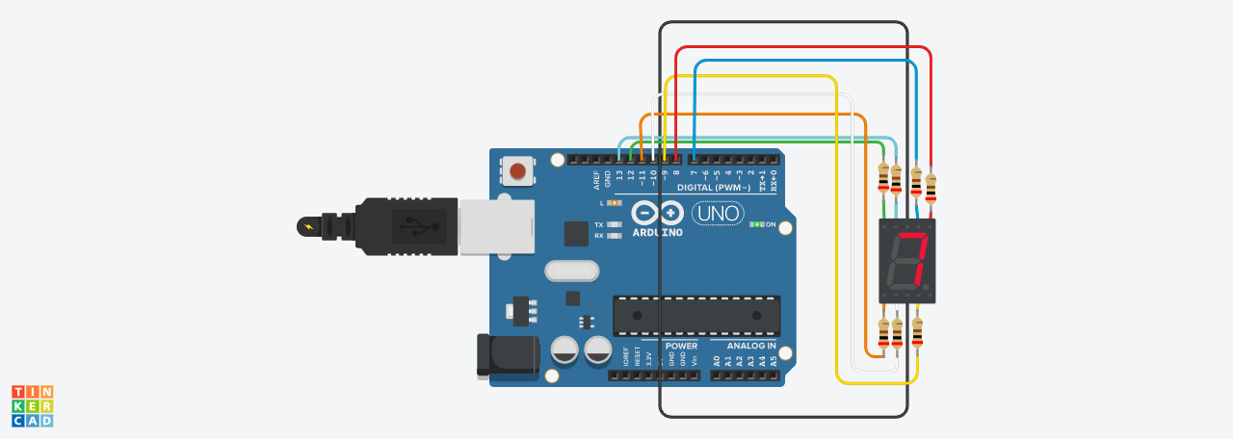

4.

int f = 13;

int g = 12;

int e = 11;

int d = 10;

int c = 9;

int b = 8;

int a = 7;

void setup()

{

pinMode(f, OUTPUT);

pinMode(g, OUTPUT);

pinMode(e, OUTPUT);

pinMode(d, OUTPUT);

pinMode(c, OUTPUT);

pinMode(b, OUTPUT);

pinMode(a, OUTPUT);

}

void write_a()

{

digitalWrite(g, 0);

digitalWrite(f, 0);

digitalWrite(e, 0);

digitalWrite(d, 1);

digitalWrite(c, 0);

digitalWrite(b, 0);

digitalWrite(a, 0);

}

void write_b()

{

digitalWrite(f, 0);

digitalWrite(g, 0);

digitalWrite(e, 0);

digitalWrite(d, 0);

digitalWrite(a, 0);

digitalWrite(b, 0);

digitalWrite(c, 0);

}

void write_c()

{

digitalWrite(f, 0);

digitalWrite(c, 1);

digitalWrite(a, 0);

digitalWrite(b, 1);

digitalWrite(g, 1);

digitalWrite(e, 0);

digitalWrite(d, 0);

}

void write_d()

{

digitalWrite(e, 0);

digitalWrite(f, 0);

digitalWrite(a, 0);

digitalWrite(b, 0);

digitalWrite(g, 1);

digitalWrite(c, 0);

digitalWrite(d, 0);

}

void write_e()

{

digitalWrite(f, 0);

digitalWrite(g, 0);

digitalWrite(e, 0);

digitalWrite(d, 0);

digitalWrite(c, 1);

digitalWrite(b, 1);

digitalWrite(a, 0);

}

void write_f()

{

digitalWrite(f, 0);

digitalWrite(g, 0);

digitalWrite(e, 0);

digitalWrite(d, 1);

digitalWrite(c, 1);

digitalWrite(b, 1);

digitalWrite(a, 0);

}

void loop()

{

write_a();

delay(1000);

write_b();

delay(1000);

write_c();

delay(1000);

write_d();

delay(1000);

write_e();

delay(1000);

write_f();

delay(1000);

}



5.

int f = 13;

int g = 12;

int e = 11;

int d = 10;

int c = 9;

int b = 8;

int a = 7;

void setup()

{

pinMode(f, OUTPUT);

pinMode(g, OUTPUT);

pinMode(e, OUTPUT);

pinMode(d, OUTPUT);

pinMode(c, OUTPUT);

pinMode(b, OUTPUT);

pinMode(a, OUTPUT);

pinMode(A0, INPUT);

}

void zero()

{

digitalWrite(g, 1);

digitalWrite(f, 0);

digitalWrite(e, 0);

digitalWrite(d, 0);

digitalWrite(c, 0);

digitalWrite(b, 0);

digitalWrite(a, 0);

}

void one()

{

digitalWrite(f, 1);

digitalWrite(g, 1);

digitalWrite(e, 1);

digitalWrite(d, 1);

digitalWrite(a, 1);

digitalWrite(b, 0);

digitalWrite(c, 0);

}

void two()

{

digitalWrite(f, 1);

digitalWrite(c, 1);

digitalWrite(a, 0);

digitalWrite(b, 0);

digitalWrite(g, 0);

digitalWrite(e, 0);

digitalWrite(d, 0);

}

void three()

{

digitalWrite(e, 1);

digitalWrite(f, 1);

digitalWrite(a, 0);

digitalWrite(b, 0);

digitalWrite(g, 0);

digitalWrite(c, 0);

digitalWrite(d, 0);

}

void four()

{

digitalWrite(f, 0);

digitalWrite(g, 0);

digitalWrite(e, 1);

digitalWrite(d, 1);

digitalWrite(c, 0);

digitalWrite(b, 0);

digitalWrite(a, 1);

}

void five()

{

digitalWrite(f, 0);

digitalWrite(g, 0);

digitalWrite(e, 1);

digitalWrite(d, 0);

digitalWrite(c, 0);

digitalWrite(b, 1);

digitalWrite(a, 0);

}

void six()

{

digitalWrite(f, 0);

digitalWrite(g, 0);

digitalWrite(e, 0);

digitalWrite(d, 0);

digitalWrite(c, 0);

digitalWrite(b, 1);

digitalWrite(a, 0);

}

void seven()

{

digitalWrite(f, 1);

digitalWrite(g, 1);

digitalWrite(e, 1);

digitalWrite(d, 1);

digitalWrite(c, 0);

digitalWrite(b, 0);

digitalWrite(a, 0);

}

void eight()

{

digitalWrite(f, 0);

digitalWrite(g, 0);

digitalWrite(e, 0);

digitalWrite(d, 0);

digitalWrite(c, 0);

digitalWrite(b, 0);

digitalWrite(a, 0);

}

void nine()

{

digitalWrite(f, 0);

digitalWrite(g, 0);

digitalWrite(e, 1);

digitalWrite(d, 0);

digitalWrite(c, 0);

digitalWrite(b, 0);

digitalWrite(a, 0);

}

void loop()

{

int read = analogRead(A0);

if (0<=read && read<=100){

zero();

}

else if(101<=read && read<200){

one();

}

else if(201<= read && read<=300){

two();

}

else if(301<= read && read<=400){

three();

}

else if(401<= read && read<=500){

four();

}

else if(501 <= read && read<=600){

five();

}

else if(601<= read && read<=700){

six();

}

else if(701<= read && read<=800){

seven();

}

else if(801<= read && read<=900){

eight();

}

else if(901<= read && read<=1023){

nine();

}

delay(1000);

}

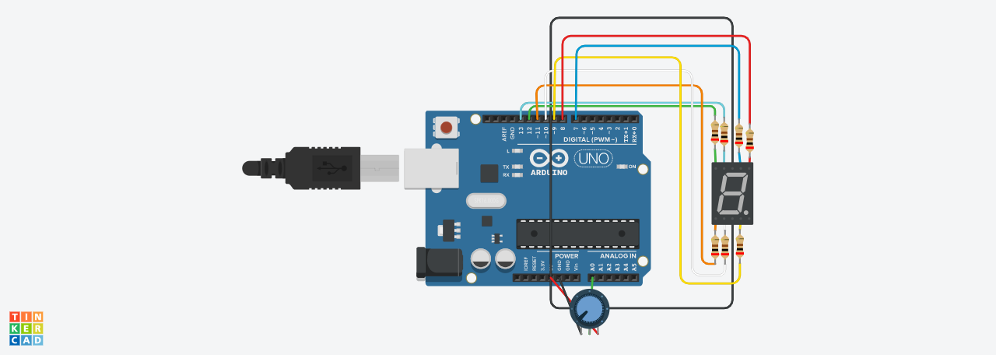

6.

int f = 13;

int g = 12;

int e = 11;

int d = 10;

int c = 9;

int b = 8;

int a = 7;

void setup()

{

pinMode(f, OUTPUT);

pinMode(g, OUTPUT);

pinMode(e, OUTPUT);

pinMode(d, OUTPUT);

pinMode(c, OUTPUT);

pinMode(b, OUTPUT);

pinMode(a, OUTPUT);

pinMode(2, INPUT);

}

void zero()

{

digitalWrite(g, 1);

digitalWrite(f, 0);

digitalWrite(e, 0);

digitalWrite(d, 0);

digitalWrite(c, 0);

digitalWrite(b, 0);

digitalWrite(a, 0);

}

void one()

{

digitalWrite(f, 1);

digitalWrite(g, 1);

digitalWrite(e, 1);

digitalWrite(d, 1);

digitalWrite(a, 1);

digitalWrite(b, 0);

digitalWrite(c, 0);

}

void loop()

{

int reading = digitalRead(2);

if(reading==0){

zero();

}

else{

one();

}

delay(1000);

}

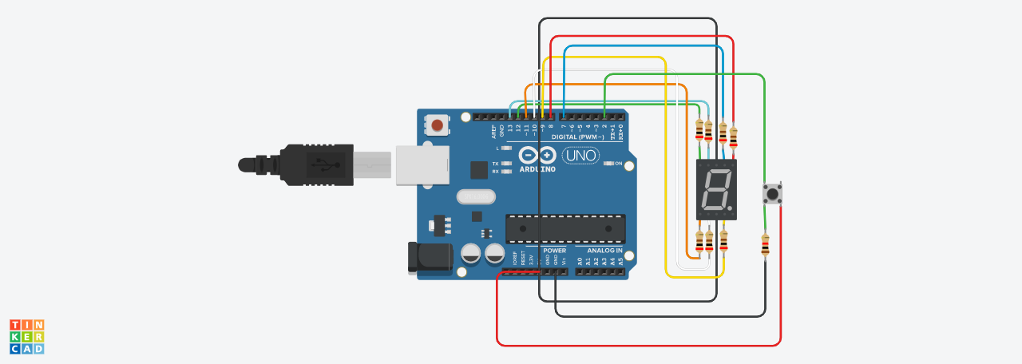

7.

void setup()

{

pinMode(2, OUTPUT);

pinMode(6, INPUT);

Serial.begin(9600);

}

void loop()

{

int read = analogRead(6);

if(read ==0){

noTone(2);

}

else{

tone(2,440);

}

Serial.println(read);

delay(100);

}

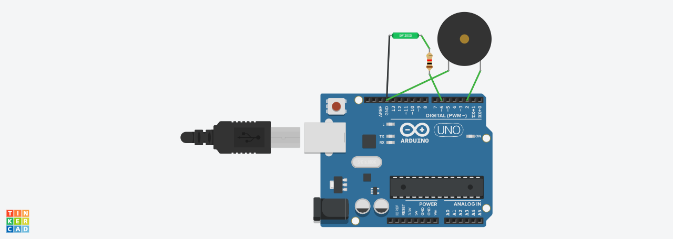

8.

void setup()

{

pinMode(2, OUTPUT);

pinMode(6, INPUT);

}

void loop()

{

int read = analogRead(6);

if(read ==0){

digitalWrite(2,LOW);

}

else{

digitalWrite(2,HIGH);

}

delay(100);

}

